Table of Contents

1. Switch Statement – Controller().display() 2

Location: 2

Reasons: 2

Strategies/ approaches: 2

2. Feature Envy – Controller().display() 3

Location: 3

Reasons: 3

Strategies/ approaches: 3

3. Large Class – Controller() 4

Location: 4

Reasons: 4

Strategies/ approaches: 4

4. Speculative Generality – View 5

Location: 5

Reasons: 5

Strategies/ approaches: 5

Smell 1: Switch Statement: Controller.display() 7

Smell 2: Large Class: Controller() 8

Smell 3: Feature Envy: Controller.Display() 9

Smell 4: Speculative Generality: View Interface 10

Refactoring Plan

# Switch Statement – Controller().display()

This was the worst smell because it covers both the Controller and Visualiser classes, and it means I have to re-write most of the Visualiser class. I will be using polymorphism and implementing an inheritance hierarchy, which might end up being a lot more work than the other smells I have found.

## Location:

Package: Interpreter

File: controller.py

Class: Controller

Method: display()

Lines: 26 - 33

## Reasons:

* The code block in the Controller.display() method that is a **switch statement** that compares an input passed into the method and calls a different display_chart() method of the Visualizer class depending on what conditional branch was executed.
* This area of the program breaks the Open/Close principle, meaning that it is not easily extensible. To extend the functionality to display more chart types I would have to add another branch to the if/else in Controller.display(), and add a whole new method in Visualizer for the new chart type, but it would contain more of the same duplicate code.

## Strategies/ approaches:

1. **Extract Method:** Firstly, I will extract the switch code block into a private method inside Controller.
2. **Move method:** Next, I will move the method into the Visualizer class.
3. **Replace Conditional with Polymorphism:** Lastly, I will replace the switch statement with an inheritance hierarchy. This will reduce the duplicate code, as well as following the Open/Close principle, making it easy to extend in the future.

# Feature Envy – Controller().display()

This was chosen as the second worst smell because it covers two classes (Controller and Validator) again, and I will have to re-write and create multiple methods.

## Location:

Package: Interpreter

File: controller.py

Class: Controller

Method: display()

Lines: 17, 18

## Reasons:

* This is the third bad smell I chose because it affects multiple modules, controller.py and validator.py.
* It is bad because the controller needs to check if some of its data is valid. It does this by accessing the data stored in the validator and performing the comparison in the controller.
* This is feature envy because all of the data is being brought into the controller and being used there.

## Strategies/ approaches:

1. **Extract method**: First I will extract the logic that compares the input data with the list of valid data columns, and turn it into its own method inside Controller.
2. **Extract method**: Second, I will do the same with the logic that compares the input parameter with the list of valid flags, turning it into its own method inside the Controller.
3. **Move method**: Then, I will move the first method into the Validator class and re-write the initial logic into the new function call.
4. **Move method**: And I will do the same for this second method. If everything goes well this shouldn’t introduce any new bugs!

# Large Class – Controller()

This bad smell was chosen as the third worst because it means creating a whole new class and moving the functionality into it. I have a plan to do it but I am unsure if complications might arise, and it means re-writing some calling code all through the application.

## Location:

Package: Interpreter

File: controller.py

Class: Controller

Method: serialize ()

Lines: 76

## Reasons:

* The controller class is used to manage the flow of data between the view (CmdView) and the various models (Validator, DataParser, Visualiser, DatabaseView), but near the end of the project it started to contain functionality that would be better suited in its own class, for example, the serialization functionality.
* I chose this as the next important bad smell to fix because it was cluttering up the Controller and making it confusing to understand what it should be doing. It will also make it easier to clean up the serialize functionality when it is in its own class.

## Strategies/ approaches:

1. **Extract Class:** Mainly, I will move the serialize method into its own class. I will do this by first creating a new module called Serialize.py, and define a new class Serializer.

I will then move the serialize() method from the Controller and into the new Serializer class, and replace the old function with a call to the new class method.

# Speculative Generality – View

This was chosen as the last smell because it affects multiple modules (fileview.py, databaseview.py, cmdview.py) and is adding unnecessary complexity to my application through a useless inheritance hierarchy, and is obfuscating some of the functionality of these classes because of the bad naming convention I chose for the View interface.

## Location:

Package: Interpreter

File: fileview.py, cmdview.py, databaseview.py

Class: FileView, CmdView, DatabaseView

Method: get(), set()

Lines: fileview.py -> line: 44, line: 10

cmdview.py -> line: 92, line: 89

databaseview.py -> line: 38, line: 62

## Reasons:

* I attempted to create an interface called View in order to generalize the reading and writing of data to and from different domains with get() and set() methods.. I then implemented this interface with CmdView, FileView, and DatabaseView.
* The problem is that I never ended up implementing all of the functionality. DatabaseView implemented both get() and set(), but FileView and CmdView only implemented get(), while set() remained un-implemented.
* The empty set() methods are cluttering up the respective classes.
* Using such basic names as get and set makes the functionality of the modules vague. Removing the interface would mean these methods could be renamed to better describe their behaviour, making the code easier to understand in these three modules.

## Strategies/ approaches:

1. **Collapse Hierarchy:** I will first remove the implementing classes dependency on the interface by removing the empty set() methods, and making them no longer inherit from View. Once this is done I can safely delete the View.py ABC module.
2. **Rename Method:** Next, I will rename the methods that were used by the interface, and name them to describe their behaviour more clearly.

Sub-Steps: *[old-name] > [new-name]*

1. FileView.get() > FileView.read_file()
2. DatabaseView.set() > DatabaseView.insert()
3. DatabaseView.get() > DatabaseView.retrieve()
4. CmdView.do_get() > CmdView.do_read()
5. **Rename Class:** I will also rename the classes because they no longer need to indicate an interface implementation. This will hopefully make their purpose easier to understand.

Sub-Steps: *[old-name] > [new-name]*

1. FileView > FileReader
2. DatabaseView > Database

I won’t rename CmdView because I feel the name accurately reflects the module’s purpose as a cmd-line interface (View in MVC). However, renaming FileView and DatabaseView makes sense considering they are no longer implementing the View interface.

Evaluation

# Smell 1: Switch Statement: Controller.display()

The **Extract Method** and **Move Method** steps for refactoring this smell went as expected. However, the third step (**Replace Conditional with Polymorphism**) was interesting because to condense the switch statement I experimented with using a dictionary that contained the input flags as keys and, as values, store lambdas to call the different display_chart() functions.

By doing this I realized I didn’t need the polymorphism at all, and instead I could just condense the duplicate display_chart() functions into one function using the **Consolidate Conditional Expression** refactoring technique.

I ended up doing this by keeping the dictionary with the input flags as keys, but instead of storing lambdas in the values, I stored the associated pygal object for each input flag.

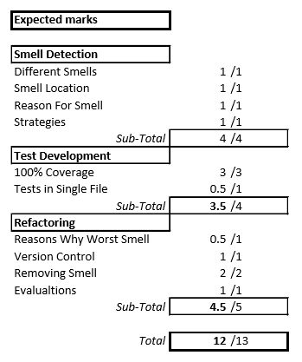Now the pygal object would be selected from the dictionary (using the flag passed in by the Controller) and inserted into the (now consolidated) build_chart() function, which returned the pygal object with the data and title inserted, and then rendering it.

I was happy with this solution, because even though I chose the wrong refactor technique in my planning, my final result was much cleaner than I expected it would be.

***Final Note:*** *This refactoring pass was good because it fixed the duplicate code bad smell that was in the Visualiser class.*

# Smell 2: Large Class: Controller()

This bad smell was not as bad to refactor as I thought it might be. I created the new serializer.py module and moved the Controller.Serialize() method into the Serializer class.

I only had to change one line of code which was the db_contents that would be used to Serialize. But this was not a problem.

I forgot, though, that I would have to inject the new dependency into the controller’s constructor through main.py. But this was fine once I remembered to do it.

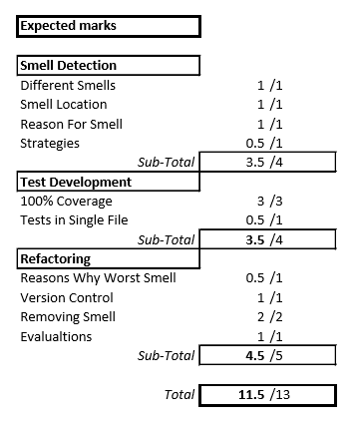

# Smell 3: Feature Envy: Controller.Display()

Refactoring this smell was straight forward to begin with, but I quickly realized my design was worse than I originally thought! Once I had **extracted** and **moved** the two methods into the Validator class, I realized I had stored the valid flags for the Visualizer class inside the Validator class, when they should be in the Visualizer class!

When initially writing the code, I thought it would make sense for the Validator class to ‘validate’ everything. But I decided now it was better suited to move this functionality out of the Controller and Validator, and into the Visualizer, especially since the Visualizer was now storing its own list of flags. (This is also a part of the design for my whole application that needs to change, and I don’t know why I didn’t think of it earlier!!)

It also meant I could get rid of the lists (dead code) I was using to make these comparisons within the Validator class, which cleaned it up.

***Final Note:*** *I realized I could get rid of this functionality entirely (calling Boolean functions from the Controller to check for validity) by simply placing some assertions into the Visualizer class, BUT, I think that would be outside the scope of this bad smell, so I decided to leave the functionality as it is.*

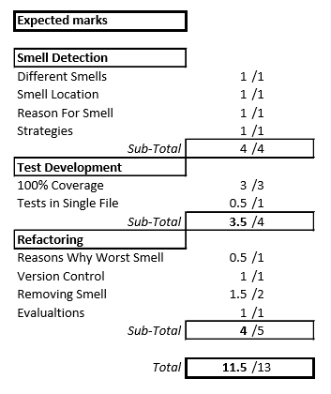

# Smell 4: Speculative Generality: View

All of the steps for this smell were fairly basic, and consisted of renaming things. I thought it would create some bugs or other mess, but it was easier than I thought. It was just time consuming to make sure I had changed all of the function calls etc. (which is why I did all of the renaming in separate steps/commits).

